**MATLAB/Octave - Vectors and Matrices**

**#assign matrix to variable A, semicolon used here to split rows**

>> A = [1 2; 3 4; 5 6]

A =

1 2

3 4

5 6

**#another way of defining matrix**

>> A = [1 2;

>> 3 4;

>> 5 6]

A =

1 2

3 4

5 6

**#row vector or 1*3 matrix**

>> V = [1 2 3]

V =

1 2 3

**#column vector or 3*1 matrix**

>> v = [1; 2; 3]

v =

1

2

3

**#range of values with fixed interval with both sides inclusive**

>> 1:0.1:2

ans =

1.0000 1.1000 1.2000 1.3000 1.4000 1.5000 1.6000 1.7000 1.8000 1.9000 2.0000

**#sequence of value with default step size of 1**

>> 1:6

ans =

1 2 3 4 5 6

**#ones matrix of 2*3 size, here 2 is row and 3 is column**

>> ones(2,3)

ans =

1 1 1

1 1 1

**#twos matrix by multiplying 2 with ones matrix**

>> c = 2*ones(2,3)

c =

2 2 2

2 2 2

**#another way of defining the twos matrix**

>> c = [2 2 2; 2 2 2]

c =

2 2 2

2 2 2

**#zeros matrix of 1*3 size**

>> w = zeros(1,3)

w =

0 0 0

**#random matrix of 1*3 size with values between 0 and 1**

>> w = rand(1,3)

w =

0.8147 0.9058 0.1270

**#random matrix of 3*3 size with values between 0 and 1**

>> rand(3,3)

ans =

0.9134 0.2785 0.9649

0.6324 0.5469 0.1576

0.0975 0.9575 0.9706

**#random matrix from Gaussian distribution with mean=0 and standard deviation=1**

>> w = randn(1,3)

w =

0.7254 -0.0631 0.7147

**#expression**

>> w = -6 + sqrt(10) * (randn(1,1000));

**#plot histogram for above expression**

>> hist(w)

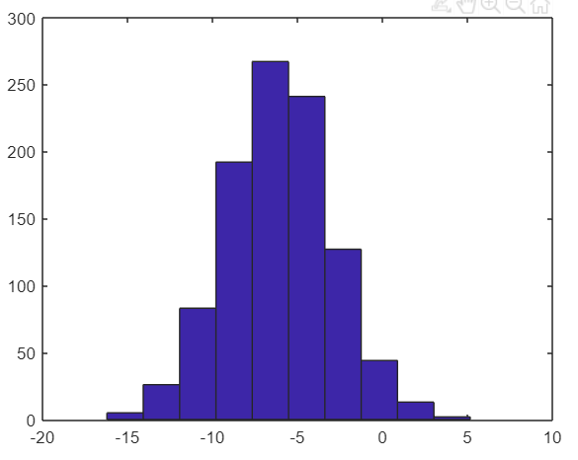

**#plot histogram with new bin size=50**

>> hist(w, 50)

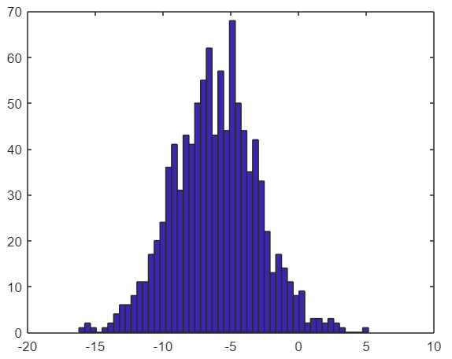

**#identity matrix of 5*5 size**

>> eye(5)

ans =

1 0 0 0 0

0 1 0 0 0

0 0 1 0 0

0 0 0 1 0

0 0 0 0 1

**#identity matrix of 3*3 size**

>> I = eye(3)

I =

1 0 0

0 1 0

0 0 1

**#seek help for any method/function/keyword**

>> help eye

eye Identity matrix.

eye(N) is the N-by-N identity matrix.

eye(M,N) or eye([M,N]) is an M-by-N matrix with 1's on

the diagonal and zeros elsewhere.

<.. more>